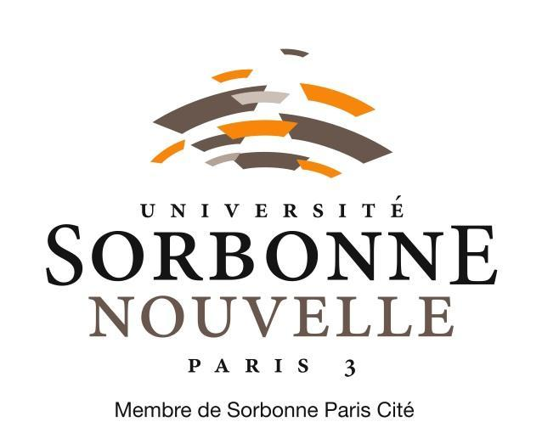

Paris, June 25th, 2019

MAISON DE LA RECHERCHE

DIRVED



Person to contact : Ewa Rakowska

**CALL FOR POST-DOCTORAL PROJECTS 2020**

In order to increase the attractiveness of the University Sorbonne Nouvelle - Paris 3, the Research Committee launches its annual call for applications to hire two post-doctoral researchers for 2020.

The selected candidates will be recruited on a single twelve months contract and will be attached to one of the research centres of the University. The contract will start on January 1st, 2020.

Applications will be submitted by the heads of the research centres. Applications involving several research centres of the institution are eligible. Projects on texts corpora will be particularly appreciated.

The Research Committee will be in charge of the assessment and selection of candidates.

**Conditions**

◆ **Required degree** : Phd or equivalent.

Vivas must have taken place between Januray, 1st, 2017 and the date of application.

◆ **Candidates who obtained their PhD in a French university different from Sorbonne Nouvelle are eligible.**

◆ **No conditions of nationality**

◆ The applicants should not have already done a post-doctoral project in University Sorbonne Nouvelle.

◆ **Research areas** : all subjects represented at Sorbonne Nouvelle.

**assessment criteria**

◆ **Academic quality of the project**

◆ **Quality of the methodology**

◆ **Inclusion and contribution to the research centre**

**Documents required**

◆  The present application

◆ Thesis report and thesis abstract: for PhDs who do not have those documents, a letter explaining the decision of the jury should be included.

◆  A detailed CV

◆  A 5-page post-doctoral research project with a state of the art and a selected bibliography.

◆  A description of how the research project could be integrated in the current research projects, and contribute to the research unit(s).

◆  A reference letter from the head(s) of the research centre explaining the importance and the relevance of the project for the centre

**application process**

◆ The applications will be submitted by the head of the research units. If a unit submits several applications, it has to established an order of preference of those applications.

◆

[recherche@sorbonne-nouvelle.fr](mailto:recherche@sorbonne-nouvelle.fr)

[ewa.rakowska@sorbonne-nouvelle.fr](mailto:ewa.rakowska@sorbonne-nouvelle.fr)

[leo.barron@sorbonne-nouvelle.fr](mailto:leo.barron@sorbonne-nouvelle.fr)

◆****

You will receive, after the deadline, a confirmation that your application has been received. If you do not receive this confirmation after one week, please ask for it.

For extra information, you can ask [ewa.rakowska@sorbonne-nouvelle.fr](mailto:ewa.rakowska@sorbonne-nouvelle.fr) and [leo.barron@sorbonne-nouvelle.fr](mailto:leo.barron@sorbonne-nouvelle.fr).

The selection will happen during the November meeting of the Research Committee.

The Vice-President of the Research Committee,

Pauline Schnapper

**APPLICATION**

**POST-DOCTORAL PROJECT 2020**

**Université Sorbonne Nouvelle – Paris 3**

**RESEARCH CENTRE**

Name of the centre:

Name of the head of the centre:

**APPLICANT**

* Family name :

* First name :
* Date and place of birth  :
* Nationality :
* Address :
* Phone :
* Mail(s) :
* **PhD :**

Thesis subject  :

Institution that delivered the PhD :

Date of delivery :

Research director :

* **Informations about the project :**

|  |  |
| --- | --- |
| **Scientific disciplines** | **Name and number of the centre** |
| **Title of the project** *(180 characters maximum ) :* | |
|  | |

In , the

Signature of the applicant :